1. Day of the Year :
#CODE:
import java.time.LocalDate;

class Solution {
public int dayOfYear(String date) {

LocalDate d = LocalDate.parse(date);

return d.getDayOfYear();
}
}

OUTPUT:
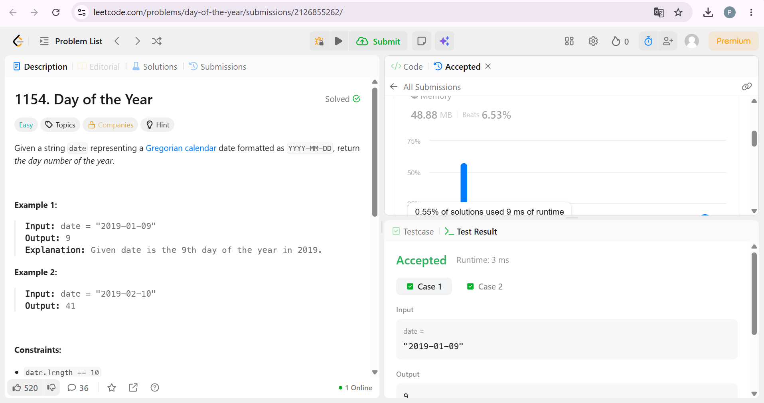

2. Day of the Week :
#CODE:
import java.time.LocalDate;

class Solution {
public String dayOfTheWeek(int day, int month, int year) {

LocalDate date = LocalDate.of(year, month, day);

return date.getDayOfWeek().toString().substring(0, 1)
+ date.getDayOfWeek().toString().substring(1).toLowerCase();
}
}

OUTPUT:
